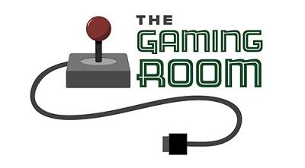

Draw It or Lose It

CS 230 Project Software Design Template
Version 1.0

Table of Contents

1.CS 230 Project Software Design Template 1
Table of Contents 2
Document Revision History 2
Executive Summary 3
Design Constraints 3
System Architecture View 3
Domain Model 3
Evaluation 3
Recommendations 5
2.Operating Platform: <Recommend an appropriate operating platform that will allow The Gaming Room to expand Draw It or Lose It to other computing environments.> 5
3.Operating Systems Architectures: <Describe the details of the chosen operating platform architectures.> 5
4.Storage Management: <Identify an appropriate storage management system to be used with the recommended operating platform.> 5
5.Memory Management: <Explain how the recommended operating platform uses memory management techniques for the Draw It or Lose It software.> 5
6.Distributed Systems and Networks: <Knowing that the client would like Draw It or Lose It to communicate between various platforms, explain how this may be accomplished with distributed software and the network that connects the devices. Consider the dependencies between the components within the distributed systems and networks (connectivity, outages, and so on).> 5
7.Security: <Security is a must-have for the client. Explain how to protect user information on and between various platforms. Consider the user protection and security capabilities of the recommended operating platform.> 5

Document Revision History

Version | Date | Author | Comments
1.0 | 07/17/22 | Paul Velazquez | <Brief description of changes in this revision>

Instructions
Fill in all bracketed information on page one (the cover page), in the Document Revision History table, and below each header. Under each header, remove the bracketed prompt and write your own paragraph response covering the indicated information.

Executive Summary

The requirement is to design and implement a web based application that makes use of classes, subclasses, a singleton class, timers, and a large library of stock images, with some ability to render images from the library over a fixed time (30 seconds) in view of the users. The users are split into teams, with one to many users per team. The teams each require a unique name. User input will be required as a given team will need to guess at what is being rendered, and the guess will have to be checked against data that is linked to the image being rendered.

Design Constraints

One relevant design constraint that results from this application running in a distributed web-based environment is the overhead created by a large number of remote procedure calls. The efficiency of the application and the structure of the network will need to be considered. Given that there is no limit on number of players per team or number of teams, a large number of users may be using this web application at one time, which will place stress on the server(s) that may require a mitigation solution.

System Architecture View

Please note: There is nothing required here for these projects, but this section serves as a reminder that describing the system and subsystem architecture present in the application, including physical components or tiers, may be required for other projects. A logical topology of the communication and storage aspects is also necessary to understand the overall architecture and should be provided.

Domain Model

The main function is a singleton, verified by SingletonTester. Game, Team, and Player are all subclasses of the Entity class, inheriting id and name attributes from Entity. Notable methods of the subclasses are Teams addPlayer method which takes a player name as a string and populates the team with players, and Games addTeam method does likewise with Team names. Similarly with attributes, Game keeps a list of teams and Team keeps a list of players. GameService is an instance of Game with a unique ID to ensure only one copy of it is running at a given time.

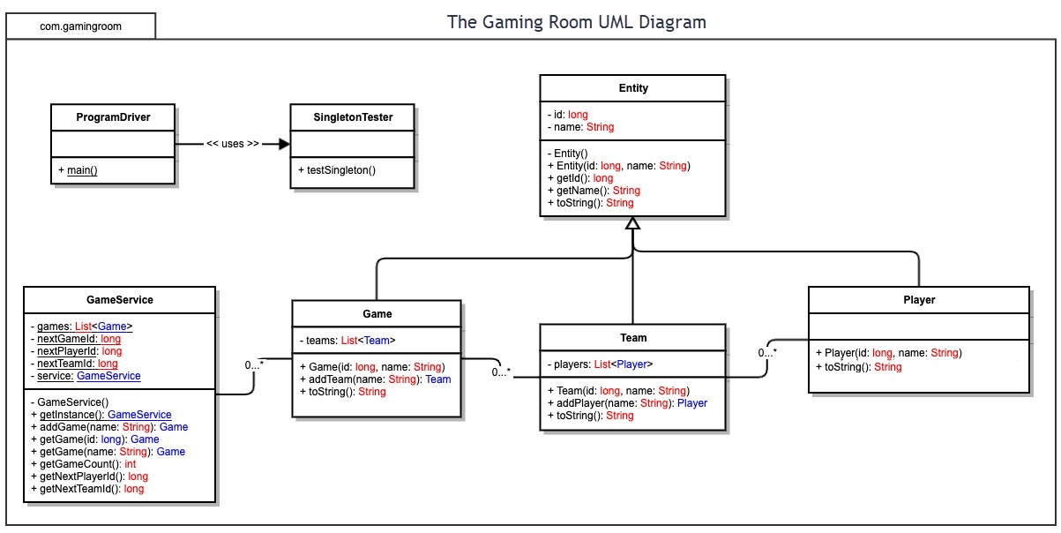

Evaluation

Using your experience to evaluate the characteristics, advantages, and weaknesses of each operating platform (Linux, Mac, and Windows) as well as mobile devices, consider the requirements outlined below and articulate your findings for each. As you complete the table, keep in mind your client’s requirements and look at the situation holistically, as it all has to work together.

In each cell, remove the bracketed prompt and write your own paragraph response covering the indicated information.

Development Requirements | Mac | Linux | Windows | Mobile Devices
Server Side | Mac offers the highest security of the hosting options, but at the highest cost, and the lowest availability as far as hosting options. | Linux matches Mac in security, but being open source means much lower cost and wider availability. | Windows web hosting is not the best choice for either security or cost, but may be necessary in some cases due to compatibility with windows applications. | It is possible but not ideal to use mobile operating systems to host web applications.
Client Side | Mac is fairly uniform in its requirements for different types of clients, but since it does not share development languages in common with other operating systems, developers experienced with Mac languages and IDEs would be required. | A higher degree of expertise is required when working with Linux, such as command line expertise, but overall cost is lower. | Less expertise required due to wide array of language and IDE options, but overall cost is higher than that of Linux. | Higher degree of difficulty and time commitment to support mobile devices than other operating systems, due to the larger differences in size and user input methods.
Development Tools | Languages: Swift, Objective-C  IDE: Visual Studio, xCode, Atom | Languages: Python, C++  IDE: Eclipse, PyCharm | Languages: Java, Python  IDE: Visual Studio, PyCharm | Languages: Java for Android, Swift or Objective-C for iOS  IDE: Android Studio for Android, xCode for iOS

Recommendations

Analyze the characteristics of and techniques specific to various systems architectures and make a recommendation to The Gaming Room. Specifically, address the following:

- Operating Platform: Linux would be my recommendation for expanding Draw It or Lose It. The benefits of Linux are the low cost, ease of use, wide availability of hosting options, and high security. The drawbacks of Linux are in the difficulty and expertise required when using Linux web hosting, and potential compatibility issues. It does not appear that compatibility issues will become relevant given the requirements of this project.

- Operating Systems Architectures: The core of the Linux operating system is the kernel, which in the example of Linux, supports any hardware environment. Passing commands to the kernel from the user is the shell. There are two types of shell, graphical and command line, with command line being more widely used in Linux due to lower overhead compared to graphical.

- Storage Management: There are many cloud-based systems available for Linux. Many of these are even free, however due to the possible need for encryption and the size requirement for storing thousands of images, a paid solution will likely be required. Another option would be a RAID array (1 + 0, 0 + 1, or 5) on a storage server.

- Memory Management: Linux supports virtual memory which is the technique of using a disk as an extension of random access memory. This effectively increases the amount of random access memory available to an application, which Draw It or Lose It would benefit from. Linux uses a Virtual Memory Primer to avoid applications accessing physical memory directly, which would be inefficient since physical memory is not always allocated contiguously.

- Distributed Systems and Networks: In a distributed system, different servers in a network are responsible for handling the different aspects of an application, such as one server handling data and another the presentation. Distributed systems increase efficiency of complex applications and avoid single points of failure, but are more complex to design and implement, and opportunities for failure increase as a distributed system expands.

- Security: Linux provides a unique edge in security compared to other operating system choices, because open source design means that underlying code for Linux operating systems has been reviewed extensively by the various technology communities. This extensive review results in exploits, bugs, and potential threats being found and eliminated at much higher rates compared to Windows or Mac operating systems. As noted earlier, another way that security can be maximized is by The Gaming Room paying for encrypted storage, which could be beneficial since it will be handling user names and other user inputs.

